February 2, 2023

Hayden Atchley

HSL Developers

CE 664

Dream Town Development

Traffic Impact Analysis

Table of contents

1. Introduction 2

1.1 Purpose 2

1.2 Study Level 2

2. Proposed Development 4

2.1 Site Description 4

2.2 Land Use and Zoning Information 4

2.3 Site Plan 6

3. Study Area Conditions 8

3.1 Street Conditions 9

3.2 Adjacent Land Uses 12

3.3 Site Accessibility 12

4. Analysis of Existing Conditions 13

4.1 Physical Characteristics 13

4.2 Traffic Volumes 13

4.3 Level of Service 15

4.4 Transportation Safety 17

References 18

Appendix A — ITE Trip Generation Reference 19

Appendix B — Synchro LOS Analysis (Existing) 26

# 1. Introduction

HSL Developers is proposing the development of Dream Town, a multi-use site containing a restaurant and a mixed-use office/retail building. This section contains information on the purpose of the report and the study level of the proposed development.

## 1.1 Purpose

This report presents a Traffic Impact Analysis (TIA) for the proposed Dream Town development. This TIA was completed to fulfill requirements from Provo City and the Utah Department of Transportation (UDOT) for new development, and was done in accordance with UDOT guidelines to apply for an access permit (Utah Department of Transportation 2019). The TIA identifies current traffic patterns—including traffic volume counts—in the study area, and projects traffic volumes to opening day and five years after opening (2024 and 2029, respectively).

## 1.2 Study Level

UDOT Administrative Rule R930-6-8(4) (Utah Department of Transportation 2019) sets forth general requirements for an access permit, including determining the application level. The proposed development will contain an 8,000 ft2 high-turnover restaurant (Institute of Transportation Engineers (ITE) land use code 932) and a 32,000 ft2 office/retail building, half of which (18,000 ft2) will be a general office location (ITE land use code 710), and the remaining half (18,000 ft2) will be a hardware store (ITE land use code 816). From the ITE Trip Generation Manual (Institute of Transportation Engineers 2021), these locations are expected to generate 1264 weekday trips and 166 PM peak trips (see Appendix A). These trip rates, along with the land use and respective development sizes, necessitate a level II application.

A Level II application requires the following:

* Analysis area includes intersection of site access drives with state highways and any signalized and un-signalized intersection within access category distance of property line
* Design years are opening day and five years after project completion
* Traffic is identified for weekday AM and PM peak, and special peak hour as necessary
  + **N.B. This analysis only includes PM peak traffic due to the scope of the assignment**
* Data collection includes:
  + Daily and turning movement counts
  + Site and adjacent roadway/intersection geometrics
  + Information on traffic control devices
  + Crash data
* Trip generation following the ITE Trip Generation Manual or other ITE procedures
* Trip distributions and assignment (existing, site, background, and future volumes in analysis area)
* Conflict and capacity analysis
* Traffic signal impacts
* Right-of-way identified, including no- and limited-access control lines
* Includes safe operational design needs and concerns with accompanying mitigation measures

# 2. Proposed Development

This section describes the plans for the development, including site location, land use, zoning information, and the the site plan itself.

## 2.1 Site Description

The proposed Dream Town development is located in southern Provo, in Utah. The site is located on the west side of University Avenue (US-189), between 1200 S and Towne Centre Drive. This location is just east of the Provo Towne Centre mall, which is a large retail and dining center and a large generator of trips. The location is also near (to the north of) the intersection of I-15 and University Avenue. Figure 2.1 shows a map of the site area. Four intersections are included in the analysis:

* 1200 S / Towne Centre Blvd. (stop-controlled)
* 1200 S / University Ave. (signalized)
* Towne Centre Dr. / Towne Centre Blvd. (signalized)
* Towne Centre Dr. / University Ave. (signalized)

## 2.2 Land Use and Zoning Information

The proposed Dream Town development has two development pads, with one pad containing a sit-down restaurant and the other pad containing a mixed-use office/retail location. The retail location is intended to be a hardware/paint store. Table 1 shows these land uses along with their ITE land use codes and respective square footage.

The site area is zoned as SC3, which is a Regional Shopping Center. The primary use of this land is for commercial and service uses to serve needs of people living in an entire region. It is located close to freeways & major arterials for easy access (Provo City Utah 2022a, chap. 14.20). Figure 2.2 provides a section of the Provo zoning map (Provo City Utah 2022b) with the site location marked.

|  |
| --- |
| Figure 2.1: Map of the site location. |

**Table** **1:** Proposed Land Use and Sizes

| Development Pad | Proposed Land Use | ITE Land Use Code | Area (sqft) |
| --- | --- | --- | --- |
| A | Sit-Down Restaurant | 932 | 8 000 |
| B | General Office Building | 710 | 18 000 |
| B | Hardware/Paint Store | 816 | 18 000 |

|  |
| --- |
| Figure 2.2: Provo zoning map, cropped to vicinity of the site. |

## 2.3 Site Plan

Figure 2.3 shows a site plan for the proposed development. Note that Pad C is not included in this analysis, as it has already been developed. This site map is still preliminary, and will be updated in a future draft of this report.

|  |
| --- |
| Figure 2.3: Site plan for proposed Dream Town development. |

# 3. Study Area Conditions

The study area for this analysis includes the streets adjacent to the site as well as their intersections. These streets are 1200 S on the north, University Ave. / US-189 on the east, Towne Centre Blvd. on the west, and Towne Centre Dr. on the south. Note that there is existing development between Dream Town and Towne Centre Dr. All of the intersections in the TIA are signalized with the exception of the Town Centre Blvd. / 1200 S intersection, which is stop-controlled. This is shown in Figure 3.1.

|  |
| --- |
| Figure 3.1: Map of basic intersection characteristics in TIA area. |

## 

## 3.1 Street Conditions

Detailed information on the streets in the study area is provided below. This information is summarized in Table 2.

**Table** **2:** Summary of Adjacent Street Configuration

| Road Name | Direction | NB/EB Lanes | SB/WB Lanes | Speed Limit (mph) | Median/TWLTL |
| --- | --- | --- | --- | --- | --- |
| 1200 S | E/W | 2 | 2 | - | Median |
| University Ave / US-189 | N/S | 3 | 3 | 35 | TWLTL |
| Towne Centre Blvd | N/S | 1 | 2 | 25 | TWLTL |
| Towne Centre Dr | E/W | 2 | 2 | 30 | Median |

###### 

###### 1200 South

1200 S is an east-west (E/W) local road which, at least in the vicinity of the study area, exists only to offer a connection between Towne Centre Bvld and University Ave. It runs about 350 feet along the north edge of the proposed Dream Town, and has 3 eastbound (EB) lanes and 2 westbound (WB) lanes. The two WB lanes offer a left- and right-turning movement, respectively (onto Towne Centre Blvd), and there is no through movement since 1200 S and Towne Centre Bvld form a T intersection. The three EB lanes offer a left, through, and right-turn movement, either onto University Avenue for the turning movements or into a parking lot for the through movement. There is no posted speed limit, and a raised median prevents left turns onto or off of this road.

###### University Avenue / US-189

University Ave is also designated as US-189, and is a major arterial running north-south (N/S) through Provo. University Ave connects with I-15 roughly 3000 feet south of the study area and has connections to many commercial developments on either side of the road. There are 3 through lanes in both directions in the study area, with 2 additional left- and 1 additional right-turn lanes/bays in both directions at the Towne Centre Dr intersection and 1 additional left- and right-turn lane/bay each in both directions at the 1200 S intersection. The posted speed limit is 35 mph, and there is a Two-Way Left Turn Lane (TWLTL) on this road for the length of the study area. There is also an appreciable shoulder on the west side of the road, and there are sidewalks on both sides, though the sidewalk on the east is separated from the road by a grassy curb strip, and the sidewalk on the west is not.

###### Towne Centre Boulevard

Towne Centre Blvd is a local street that circumnavigates the Provo Towne Centre mall. Within the study area this road runs N/S, and has 1 northbound (NB) and 2 southbound (SB) through lanes. A TWLTL runs the length of this road, though it is broken up by a bus stop located in the center of the road near the southern end of Dream Town. The TWLTL becomes two SB left turn bays at the Towne Centre Dr intersection, and there is a NB free-flow right-turn bay at the same. This road has a posted speed limit of 25 mph.

###### Towne Centre Drive

Towne Centre Dr is an E/W road that runs between Towne Centre Blvd and University Ave, and becomes East Bay Blvd east of University Ave. There is a posted speed limit of 30 mph, and there is a raised median between Towne Centre Blvd and University Ave, though the median breaks about midway, allowing a WB left turn to access the development to the south. There are 2 left- and 1 right-turn bays at the University Ave intersection in both directions, and 2 left-turn lanes and a right-turn free-flow lane at the Towne Centre Blvd intersection.

### Additional Information

There are several bus stops in the study area, as shown in Figure 3.2. Towne Centre Blvd is elevated relative to Dream Town, but there is a staircase next to the bus stop that allows for pedestrian access.

|  |
| --- |
| Figure 3.2: Map of bus stops on the studied streets. |

## 3.2 Adjacent Land Uses

As can be seen in Figure 2.2, much of the nearby land is in the same zoning category as Dream Town (SC3). This is borne out by the actual land use: there are several suburban commercial sites in this area. The most notable of these is the Provo Towne Centre mall to the east, but other locations include a Sam’s Club, several fast-food and sit-down restaurants, and multiple small hotels and gas stations.

## 3.3 Site Accessibility

University Ave provides direct access to Dream Town from I-15, as well as from downtown Provo. This is the most major road with direct access to the site, but several other roads provide access as well. Towne Centre Blvd has connections to a neighborhood northwest of the site, and East Bay Blvd provides access to University Ave near the site from southeast Provo, and has a connection to Springville via Lakeview Pkwy and I-89.

# 4. Analysis of Existing Conditions

## 4.1 Physical Characteristics

The study area contains four intersections: 1200 S / Towne Centre Blvd, a 3-way stop-controlled intersection; 1200 S / University Ave, a 4-way signalized intersection; Towne Centre Dr / Towne Centre Blvd, a 3-way signalized intersection; and Towne Centre Dr / University Ave, a 4-way signalized intersection (see Figure 3.1).

Much of the information regarding lane striping and turning movements for these intersections is given in Table 2. It is additionally worth noting that the east leg of the 1200 S / University Ave intersection is a parking lot access, and the WB lane has a designated left-turn lane and a shared right/through lane. For reference, a lane configuration diagram of these intersections is provided in Figure 4.1.

## 4.2 Traffic Volumes

Traffic turning volume counts were done at the Towne Centre Dr / University Ave and Towne Centre Dr / Towne Center Blvd intersections from 4:15–6:00 PM on January 24 (Tue) and 25 (Wed), 2023, respectively. Scheduling conflicts and limited personnel necessitated that the counts be performed for only two intersections and on different days. However, for the purposes of this report this is not a significant limitation, due to the limited scope of the assignment. The two days are considered similar enough, and volumes were estimated for the other two intersections.

From these counts and projections, 4:30–5:30 PM was determined to be the peak hour, with a peak hour factor (PHF) of 0.92. The volumes for this peak hour are presented in Figure 4.2.

|  |
| --- |
| Figure 4.1: Intersection lane diagram of the study area. |

|  |
| --- |
| Figure 4.2: Peak hour turning volumes on the studied intersections. |

## 4.3 Level of Service

A level of service (LOS) measure was used to determine the traffic performance of each intersection (and each movement within each intersection). This LOS is a measurement of average control delay per vehicle, and bins the amount of delay into groups designated by the letters A–F. These designations differ between signalized and unsignalized intersections, and are provided in the Highway Capacity Manual (HCM) (National Academies of Sciences, Engineering, and Medicine 2022). Tables 3 and 4 summarize these criteria. This analysis assumes a LOS of D or better represents acceptable conditions.

**Table** **3:** LOS Criteria for Signalized Intersection

| Average Control Delay (sec/veh) | LOS Designation |
| --- | --- |
| ≤ 10 | A |
| 10–20 | B |
| 20–35 | C |
| 35–55 | D |
| 55–80 | E |
| > 80 | F |

**Table** **4:** LOS Criteria for Unsignalized Intersection

| Average Control Delay (sec/veh) | LOS Designation |
| --- | --- |
| ≤ 10 | A |
| 10–15 | B |
| 15–25 | C |
| 25–35 | D |
| 35–50 | E |
| < 50 | F |

The existing level of service was determined based on current traffic volumes Section 4.2 and signal timings (obtained from UDOT), using the Synchro software package (Trafficware 2019). Synchro performs a LOS analysis using these and other inputs, including roadway and lane configuration. Figure 4.3 shows the results of this analysis.

|  |
| --- |
| Figure 4.3: Results of existing Synchro LOS analysis for each movement and intersection studied. |

## 4.4 Transportation Safety

# References

Institute of Transportation Engineers. 2021. *Trip Generation Manual*. 11th ed. <https://itetripgen.org/>.

National Academies of Sciences, Engineering, and Medicine. 2022. *Highway Capacity Manual 7th Edition: A Guide for Multimodal Mobility Analysis*. Washington, D.C.: National Academies Press. <https://doi.org/10.17226/26432>.

Provo City Utah. 2022a. “Provo City Code.” <https://provo.municipal.codes/Code>.

———. 2022b. “Provo City Zoning Map,” January. <https://www.provo.org/home/showpublisheddocument/8772/638095423470500000>.

Trafficware. 2019. *Synchro*. Cubic Transportation Systems. <https://support.gridsmart.com/support/solutions/articles/69000541835-synchro-studio-11-user-guide>.

Utah Department of Transportation. 2019. “Administrative Rule R930-6 (Access Management).” <https://drive.google.com/file/d/1a0YNDy9Z8bFxuE121lJP5XJNW0rw9Ft3/view?usp=embed_facebook>.

# Appendix A — ITE Trip Generation Reference

This appendix contains the ITE Trip Generation Manual references used for trip generation, including to determine the appropriate study level for this TIA. These are land use codes 710 (General Office Building), 816 (Hardware/Paint Store), and 932 (High-Turnover (Sit-Down) Restaurant), for both the daily trips and the PM peak trips.

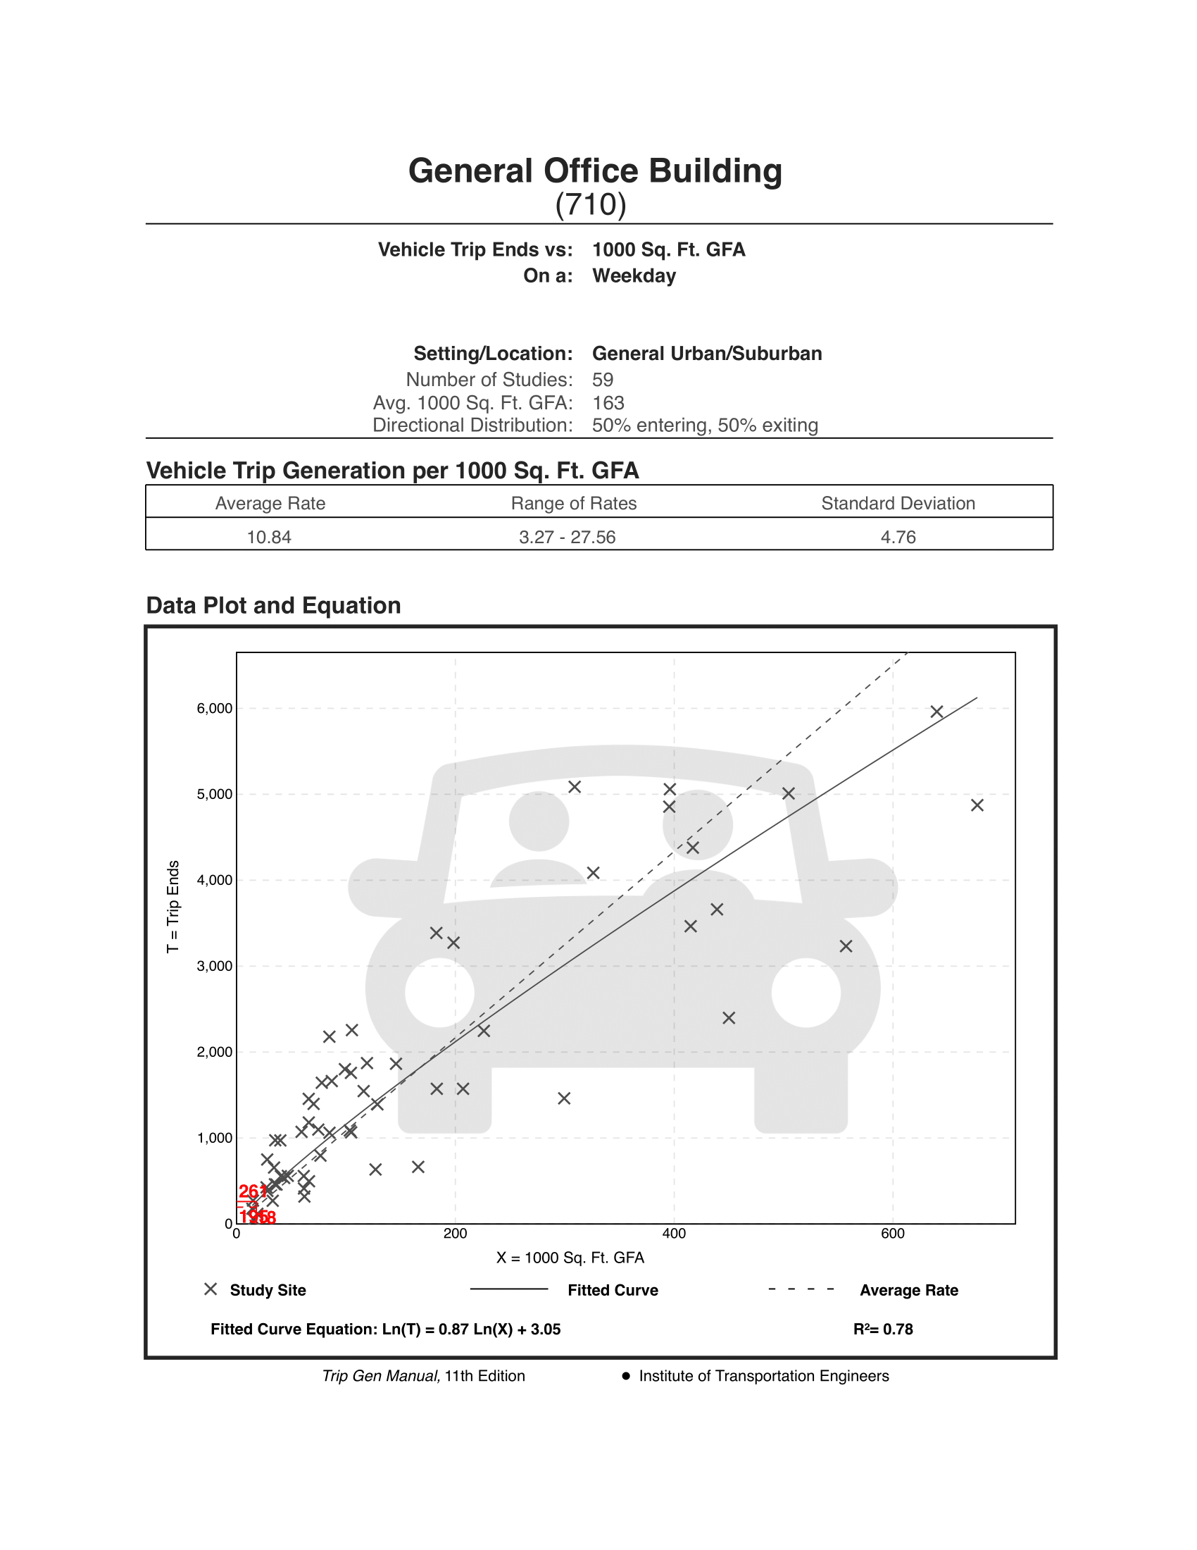 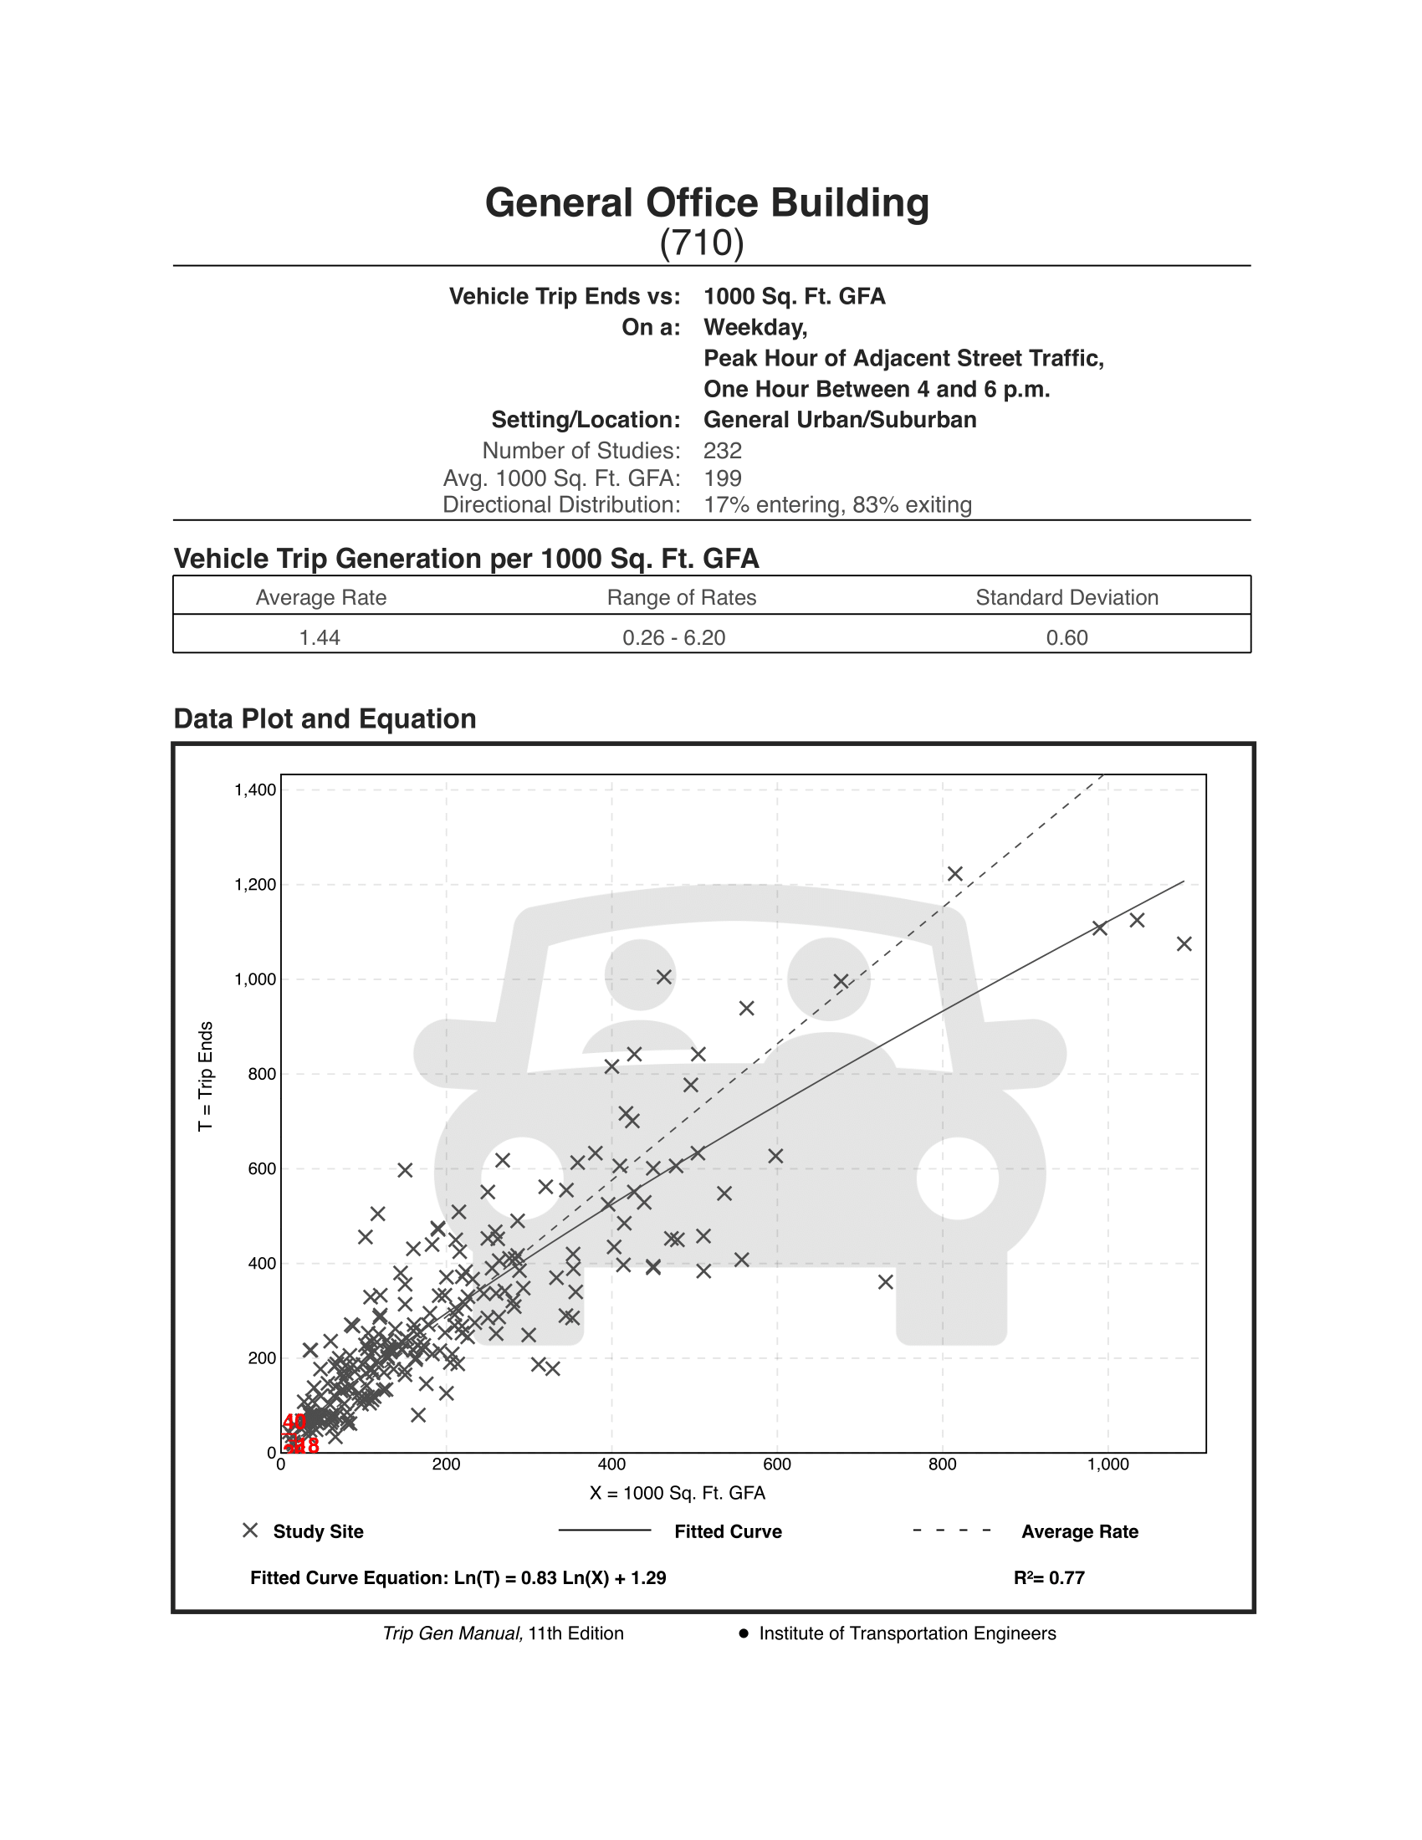

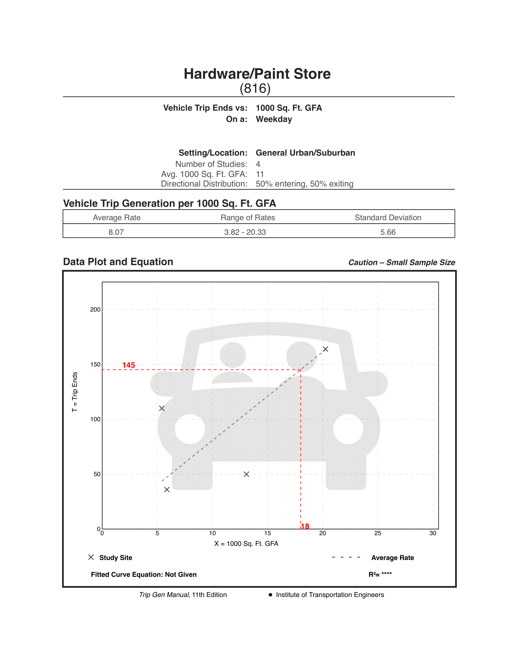 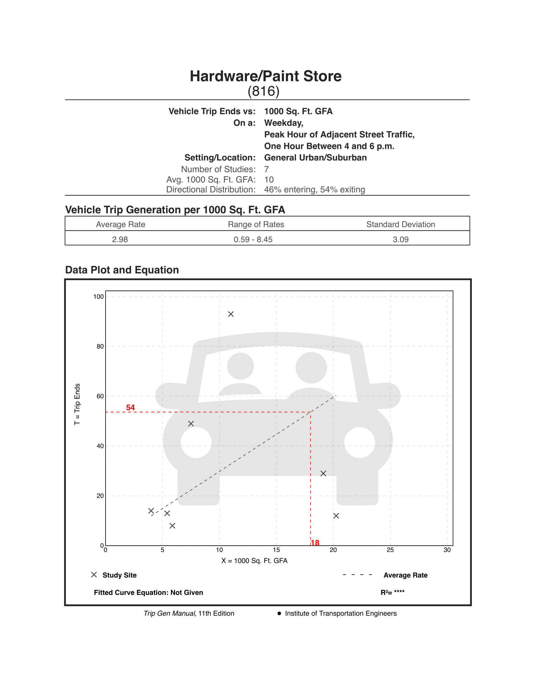

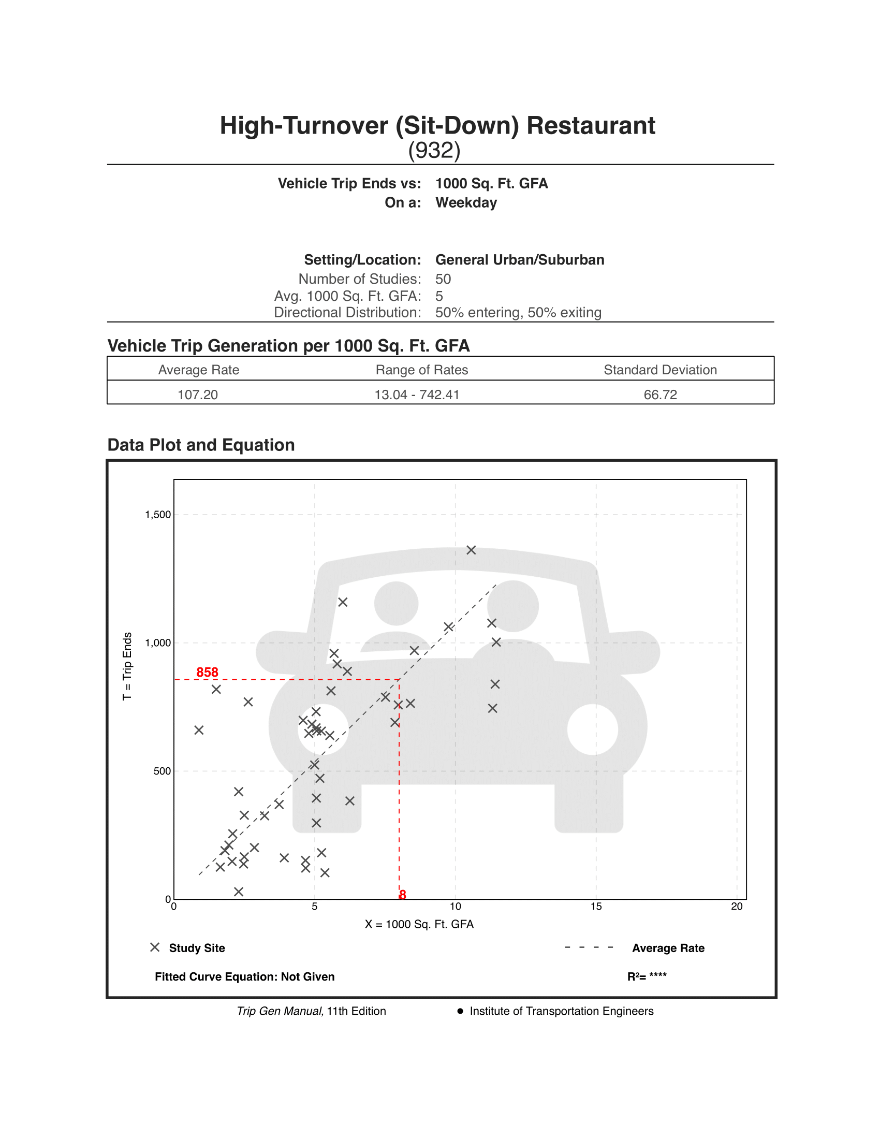 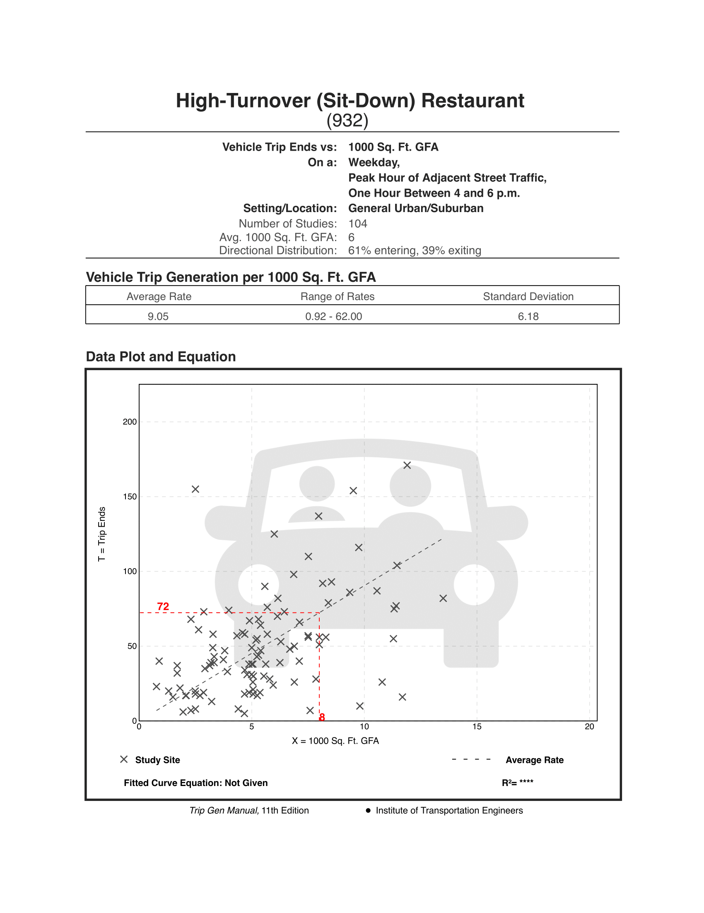

# Appendix B — Synchro LOS Analysis (Existing)

This appendix contains the results of the Synchro LOS analysis for the existing road volumes, signal timings, and lane configurations. The analysis of the all-way-stop-controlled (AWSC) 1200 S / Towne Centre Blvd intersection is given first, followed by the analysis for the remaining (signalized) intersections.

